EOSSMIC-UM-001
LA-UR-xx-xxxx

Safeguards Science & Technology Group, N-1

Nuclear Nonproliferation Division
MIC EOSS
User Manual
February 13, 2008

Author(s):
David Pelowitz
© Copyright Los Alamos National Security, LLC.
This Software was produced under a U.S. Government contract (DE-AC52-06NA25396) by Los Alamos National Laboratory, which is operated by the Los Alamos National Security, LLC (LANS) for the U.S. Department of Energy, National Nuclear Security Administration. The U.S. Government is licensed to use, reproduce, and distribute this Software. Permission is granted to the public to copy and use this Software without charge, provided that this Notice and any statement of authorship are reproduced on all copies. Neither the Government nor the LANS makes any warranty, express or implied, or assumes any liability or responsibility for the user of this Software.

Introduction

Purpose

This User Manual is intended to assist the reader in setting up and using the MIC EOSS Instrument Support Object, ISO, and Communications Support Object, CSO. It includes a description of the software along with setup and operation instructions. It does not cover the installation of the Dr. Neumann Electronic Optical Seal Software which is a requirement for the MIC software to work.

Definitions and Acronyms

Acronyms

MIC Multi-Instrument Collect
EOSS Electronic Optical Sealing System
ISO Instrument Support Object
CSO Communications Support Object

References

[1] EOSS Seal Reader Software for Windows NT/2000/XP Technical Reference, Version: 2.x, Dr. Neumann

[2] EOSS Seal Reader Software for Windows NT/2000/XP User’s Guide, Version: 2.x, Dr. Neumann

[3] EOSS Electronic Optical Sealing System, Instructions and Reference, Nov. 2003 , Dr. Neumann
[4] EOSS Electronic Optical Sealing System Crypto Token Instructions and Reference, July 2007, Dr. Neumann

Software Description

The Multi-Instrument Collect support of the Dr. Neumann/Canberra Electronic Optical Sealing System relies on the proper installation of the Dr. Neumann/Canberra EOSS Reader software. MIC uses the crypto dongle and the associated services provided by the EOSS Reader software to decrypt the communications coming from the seals. Consequently, the software provided with the EOSS must be installed and verified functional prior to configuring MIC to gather data from EOSS seals. This is CRITICAL as MIC cannot talk to the EOSS seals directly.

There are three software components associated with the MIC EOSS support: MIC_EOSSReader.exe, CoEOSSCSO.dll, and CoEOSSISO.dll. The MIC_EOSSReader.exe does the actually reading from the optical seals. MIC schedules it to run using the SCHTASKS.exe provided by the operating systems. It can be scheduled to run monthly, weekly, daily, or hourly. Under normal circumstances running once per week or once per day should be adequate. The ISO and CSO are MIC components compatible with MIC version 2.0.0.4 and above.

The CSO is sort of a dummy communications support object. It reserves a serial communications port, so that MIC cannot use that port for any other CSO. It also provides a point to connect the ISO to, following the standard MIC ISO connecting to a CSO paradigm.

The ISO schedules running the MIC_EOSSReader.exe using commands to the Windows operating system. It periodically verifies the scheduling and reschedules if necessary. It also monitors the running of MIC_EOSSReader.exe. MIC_EOSSReader.exe saves all the data it collects in a binary day file with an extension of “.ess”. It also saves this data in the registry. When the MIC ISO detects MIC_EOSSReader.exe has completed the ISO then reads the registry and makes appropriate entries in the .PFM and .CEV files as well as to the dialog boxes.

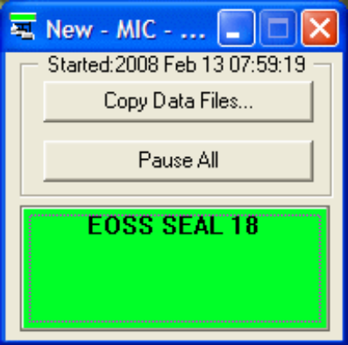
Figure 1. MIC with EOSS Instrument Support Object.

Configuration

  - Pre-MIC: The operating system utility SCHTASKS is used to automatically schedule running of the MIC_EOSSReader.exe program. This is accomplished by the MIC EOSS ISO in background under the control of a user account established for this purpose. This user account MUST have administrator privileges. After installing the Dr. Neumann/Canberra EOSS Reader software create the new account with administrator privileges, log out of the current account, and then log into the new account. While logged on to the new account, run the EOSS Reader software to verify the account can access the seals. You may need to re-install the EOSS Reader software while logged into the new account. Once you’ve verified the new account can access the seals you may log out and log back in to the account normally used.

  - MIC Configuration: The communications support object must be configured first. Select “Configuration” from the MIC dropdown menu and then in the “Multi-Instrument Collect: Configure” dialog box select “Add Comm…”. In the subsequent dialog enter a Comm Name and select the EOSS entry. If EOSS doesn’t appear here then the CoEOSSCSO.dll has not been been fully installed on your system. In this case open a command prompt window, change directory to where the CoEOSSCSO.dll is and do this command: “regsvr32 CoEOSSCSO.dll”. You may now return to MIC, close the MIC: New Communications (CSO) dialog and click on “Add Comm…” again. You’ll next be asked to select a serial communications port. This is the serial port the EOSS Serial is plugged into. The next task is to establish the MIC instrument support object. From the Multi-Instrument Collect: Configure” dialog select “Add Instrument”. In the subsequent dialog box you’ll be asked to provide the instrument name and the instrument type. Select EOSS. If EOSS doesn’t appear in the dialog box follow the steps above replacing CoEOSSCSO with CoEOSSISO.
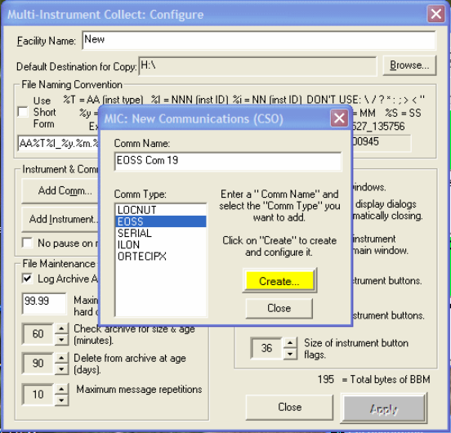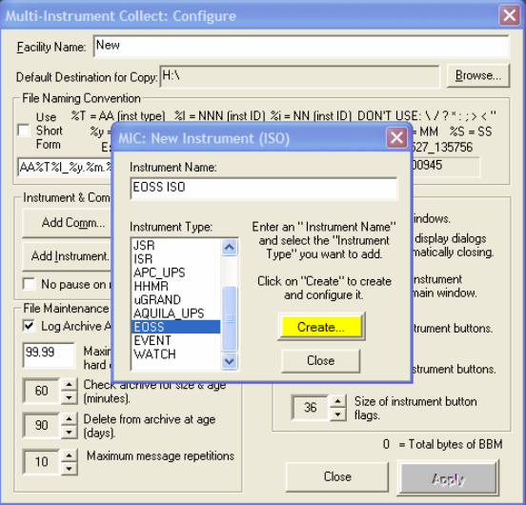
Figure 2. Creating an EOSS CSO and ISO.

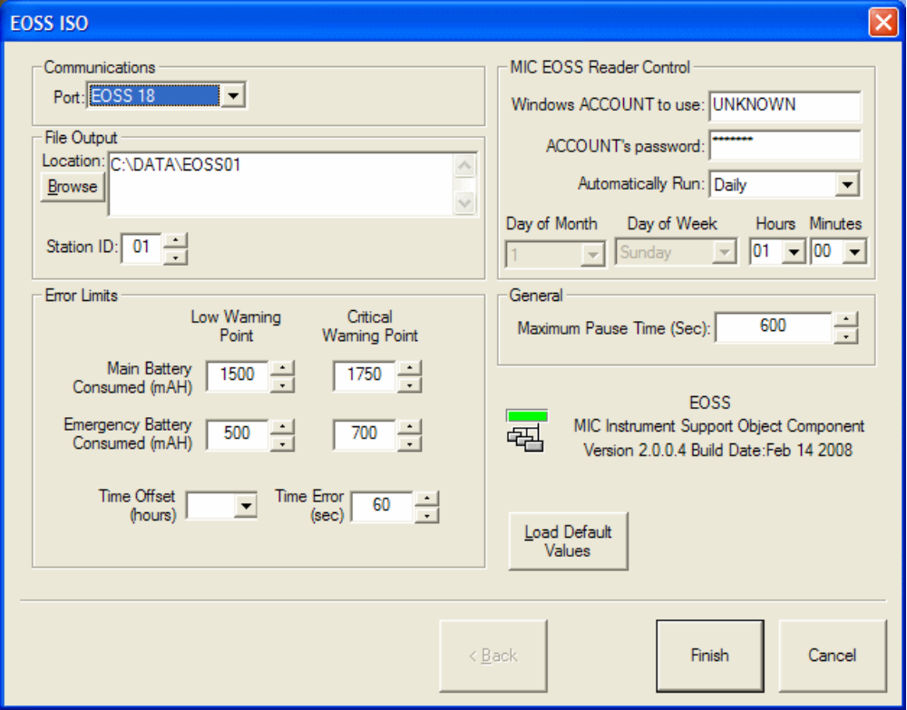
Figure 3. Initially Configuring an EOSS ISO.

Configuration of the “Communications”, “File Output”, “Error Limits”, and “MIC EOSS Reader Control” are all critical. The “Port”, “Location”, and “Station ID” are set in the same fashion as all of the other MIC Instrument Support Objects. The “Error Limits” section contains controls for setting points at which the ISO will flag potential problems such as low battery.

Use
The colored button associated with the EOSS ISO on the MIC main dialog will normally be green. It will change to yellow while the seals are being read. While yellow other EOSS readers such as the R. Neumann Consultants EOSS Reader should not be used. When the button is clicked on the EOSS ISO presents a tabbed dialog box. The first and default tab is the “Summary”. It displays a list of the EOSS devices found and a list of recent commands and responses. In the example shown in figure 4 there are three EOSSes detected and because the color is green there are no problems with them.

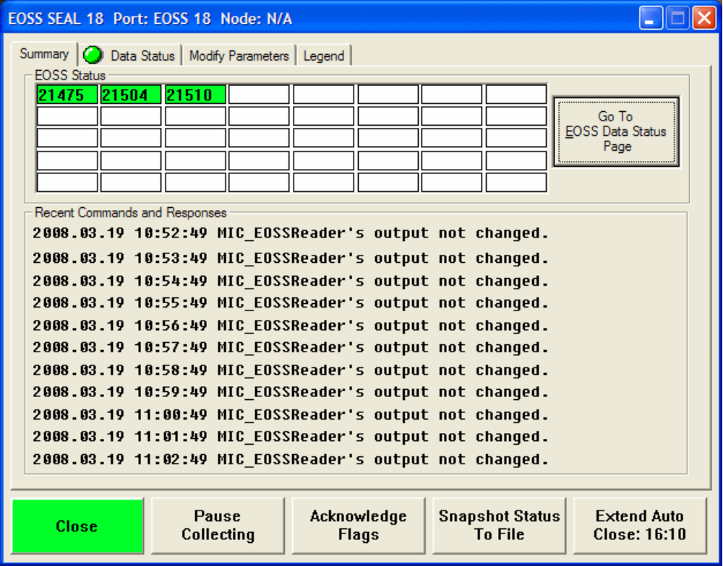
Figure 4. EOSS Summary Tab

The “Data Status” tab displays all of the collected data. The round green icons further indicate the health of the specific instruments as well as some general information. If there is a problem they will change to a red rectangle or a yellow triangle depending on the severity of the problem. The data is accessed by selecting and expanding one of the items and then selecting one of the sub-items. The collected data associated with selected item will be displayed in the right part of the Data Status dialog.
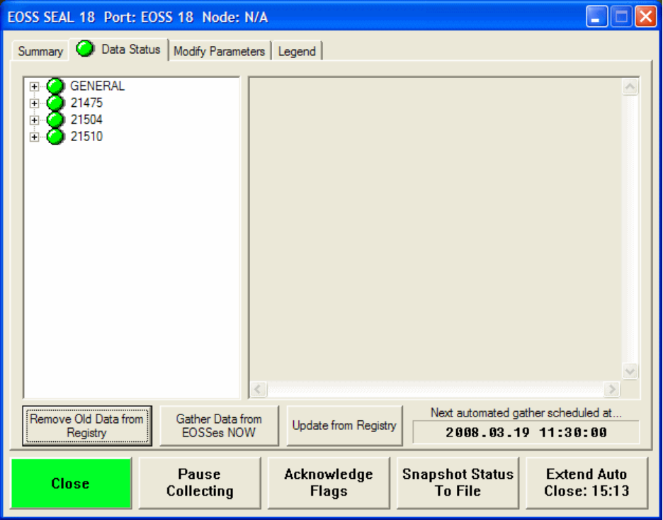
Figure 5. EOSS Data Status Tab
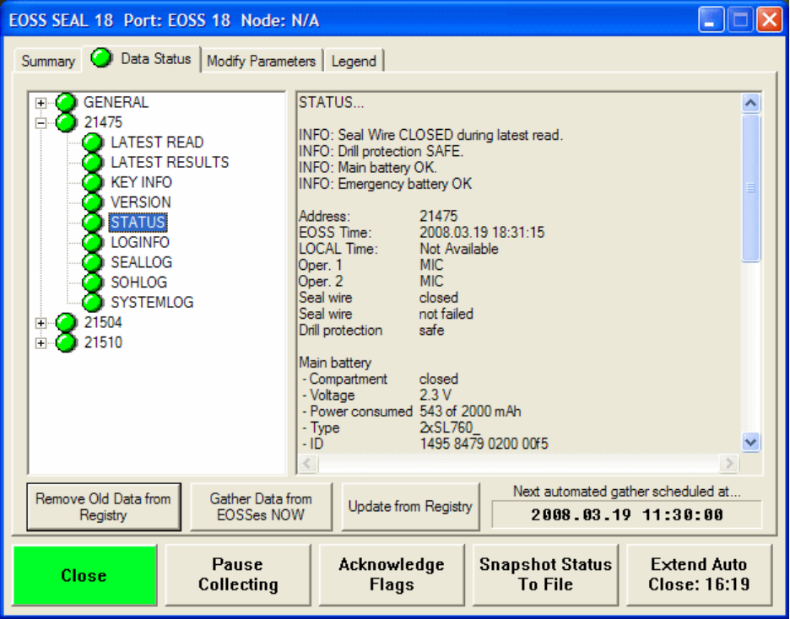
Figure 6. EOSS Data Status Tab with item selected

Near the bottom of the Data Status Tab are three buttons. “Remove Old Data from Registry” should be used when a seal has been replaced. The EOSS ISO will continue to report the old EOSS seal and will eventually mark it as being overdue update until this button removes the information from the registry. “Gather Data from EOSSes NOW” may be used to trigger a nearly immediate read of the associated EOSS seals. This may be used at any time with the exception that it should not be used while a read is in progress (yellow) or a read is being attempted by another program.

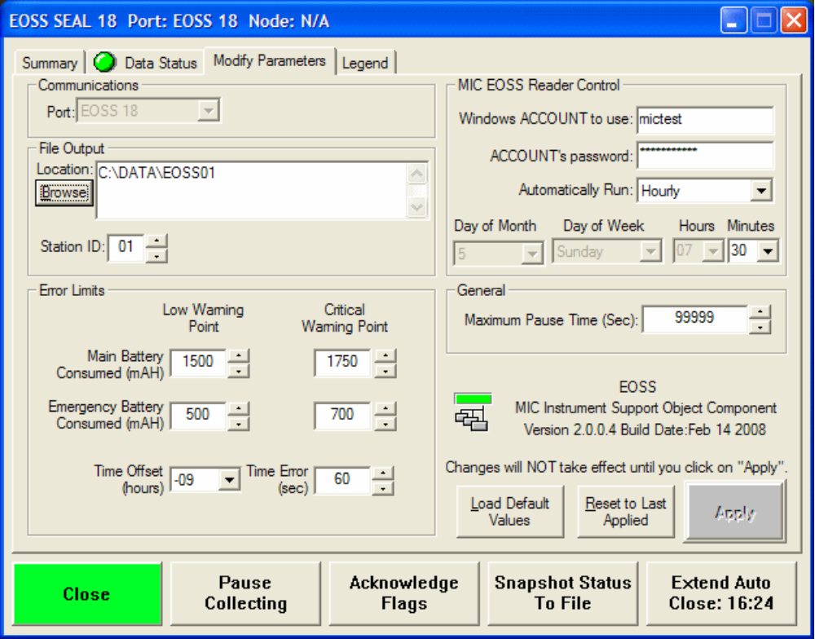
Figure 7. EOSS Modify Parameters Tab

The Modify Parameters tab provides for user configuration of various operating parameters. It is organized similar to other MIC ISOs and is used identically. The unique capability here is being able to set how often the EOSS ISO configures the application MIC_EOSSReader.exe to run. The options are monthly, weekly, hourly, and daily. The “Day of Month”, “Day of Week”, “Hours”, and “Minutes” will activate as appropriate for the “Automatically Run” selection.

The final tab “Legend” defaults to built in text but may be changed by the installer. It uses a Rich Text File format. If a file with the same name as this instantiation of the EOSS ISO exists (e.g. EOSS SEAL 18.rtf) then that file will be loaded instead of the default text. If that file doesn’t exist the EOSS ISO will look for a file with the name “EOSS.rtf” and load it if found. If that file isn’t found then the default text will be displayed as shown. Use any editor that can save the file as a Rich Text file (.rtf) to edit or create a custom display.

Performance File (PFM)
The Performance Files are text files containing date and time stamped performance information and may be read by any text editor which supports simple text only files. One file is created for each day using the configured file naming convention with a file extension of “.pfm”. The information in these files is gleaned from the various status messages as well as the status bytes in the safeguards data messages sent by the instrument.

Critical Event File (CEV)
The Critical Events Files are text files containing date and time stamped information critical to the acquisition of safeguard information and may be read by any text editor which supports simple text only files. The standard file naming convention is used with a file extension of “.cev”. They contain a subset of the information in the PFM files. The information in these files are gleaned from the various status messages as well as the status bytes in the safeguards data messages sent by the instrument.

ESS File

